Multi-Coverholder FNOL Framework – CS to AFCS (Adrian Flux)
Oct 23, 2026 · @JC

1. Purpose, scope and the core decision
Adrian Flux (AF) will run on the existing Trinity FNOL code base by adding a thin coverholder layer: AFCS on top of CS, and AFCSWebExt on top of AFCS. Every AF difference lives in an AF class or AF ruleset, reached through class inheritance, extension points or Dynamic Class Referencing (DCR). No rule in the CS layer is copied unless it is first refactored into a template plus an extension point.
In scope: web form channel, case creation and duplicate check, correspondence and PDF, AI image analysis, the policy-validation email loop with triage and AI parsing, Libra ID update and resolution, security, data, DevOps and testing.
Out of scope: changes to Libra itself, Okta tenant set-up, and AF commercial or underwriting rules not yet defined.
Assumptions
- Platform: Pega Infinity 25.1.3, Constellation UI, DX API v2.
- Class naming follows Org-Coverholder-App-Work-CaseType: AF = HCC-AF-CS-Work-FNOL. The framework keeps HCC-CS-*. Trinity keeps HCC-CS-Work-FNOL today and moves to HCC-TRI-CS-* in the future state (section 18). Application names follow the same order: AFCS and AFCSWebExt for Adrian Flux, TRICS and TRICSWebExt for Trinity in the future state. See section 5 for the coverholder layer.
- AF uses Libra for claim IDs, the same as Trinity. If AF uses a different claims system, section 12 changes.
- AF has its own policy-validation counterpart (equivalent of the Trinity validation team) reached by email. Name and mailbox to be confirmed.

The architecture decision
Two layering options exist. The doc builds on Option A because it needs the fewest changes now, and plans Option B as the future state, reached step by step through a Trinity application TRICS (section 18).
Option | Shape | Pros | Cons
A. Coverholder on coverholder (chosen) | AFCS built on CS; HCC-AF-CS-Work-FNOL inherits from HCC-CS-Work-FNOL | Minimal refactor; Trinity keeps running unchanged; fast delivery | Trinity-specific behaviour in CS leaks into AF unless placed behind an extension point; every CS change is a change for AF
B. Framework + implementations | A neutral framework layer (e.g. HCC-CSFW) with CS (Trinity) and AFCS as siblings | Clean Pega layered model; no leakage; scales to N coverholders | Requires moving Trinity rules into a new layer; larger regression
The rule that makes Option A safe: the CS layer behaves as the framework, and Trinity-specific behaviour sits only in the default implementation of an extension point. AF overrides the extension point; it never overrides a whole framework rule.

2. Current-state baseline and the generic vs specific split
Before building AFCS, every Trinity capability is tagged as Framework (reuse as is), Extend (reuse with an extension point) or Specialize (AF-only rule). This inventory is the first deliverable, because it tells you which CS rules must be refactored before AF can inherit them safely.
Capability (Trinity today) | Key rules / instances | Tag | AF treatment
Anonymous web form (custom DX component) | CSWebExt app, CS Guest User operator, OAuth client, DX component | Extend | New AFCSWebExt app and AF guest operator; same component, config-driven
Field labels, placeholders, errors, tooltips, regex | CSWebExt localization bundle | Specialize | AF bundle in AFCSWebExt ruleset; override only keys that differ
Dropdown and radio values | HCC-CS-Data-LOV table + data pages | Extend | HCC-AF-CS-Data-LOV with own table; data pages resolve class via DCR
Case creation via DX API | Case type HCC-CS-Work-FNOL, caseTypeID in component | Extend | caseTypeID read from config, not hard-coded
Duplicate check | NewDefaults on HCC-CS-Work-FNOL | Extend | Refactor into template + DuplicateCheck_Ext
Confirmation email | Correspondence rules, email account | Extend | AF templates and AF email account via config
Claim summary PDF | PDF section, attachment category | Extend | AF branding section; same generation step
AI image analysis | Queue processor, GenAI / vision connector, "Photograph of Damage" category | Framework | Reuse; AF prompt or thresholds only if they differ
Validation email to Trinity team | Outbound correspondence, recipient address | Specialize | AF recipient, template and subject format
Email listener + triage | Email account, listener, service email, email channel, triage case | Specialize | New AF email account, channel and listener; triage stays on Pega's Work-Channel-Triage-Email, AF logic in the AFCS ruleset
AI parsing of reply + business validations | Triage AI processing on Work-Channel-Triage-Email (saved in CS ruleset), parsing prompts, extraction data transforms, validation rules | Extend | Refactor CS-ruleset triage rules into template + _Ext; AF overrides _Ext in the AFCS ruleset; FNOL mapping and rules on the AF class
Review tabs for claim handler | Constellation views | Framework | Inherit; AF view override only if layout differs
Libra ID update and resolve | Flow action, edit-validate, resolve step | Framework | Reuse; ID pattern from config
Anything tagged Extend that is still Trinity-hard-coded (an email address, a case-type name, a class name, a work ID prefix, a logo) is refactored in the CS layer first, with Trinity values moved into the Trinity default implementation or into configuration.

3. Guiding principles and Pega guardrails
Specialize by class first, by extension point second, by DCR third, and by circumstancing or ruleset override only when nothing else fits. Copying a framework rule is the last resort and needs design-authority sign-off.
- Specialize at the lowest layer that owns the difference. A Trinity/AF difference belongs in HCC-AF-CS-* classes or AFCS rulesets, never in a when rule inside CS that checks "is this Adrian Flux?".
- No coverholder if logic in the framework. Conditions such as .Coverholder == "AF" scattered through CS rules are the main cause of framework rot. Use polymorphism (same rule name, different class) instead.
- Template + extension point. Each framework rule that varies is split into a fixed template that calls a small, empty-or-default _Ext rule (data transform, activity, when, section/view). AF overrides only the _Ext rule.
- No hard-coded class names, email accounts, case-type IDs, work ID prefixes or URLs. Read them from the coverholder configuration (section 6).
- Save As only into the AF class and AF ruleset, never into CS. Saving a CS rule into a AFCS ruleset but the same CS class is a ruleset override: it works only in the AFCS application context and is invisible in background processing that runs under another context. Prefer class specialization for classes you own (HCC-*). For Pega-owned classes such as Work-Channel-Triage-Email or Work-, ruleset specialization is the accepted pattern, under the conditions in section 6.
- Keep one rule, one owner. Framework rulesets (CS, CSWebExt) are owned by the framework team; AF rulesets by the AF delivery team. Branch per change, merge via review.
- Standard Pega guardrails still apply: guardrail score above 90, no custom Java or Obj-Open in UI, report definitions over Obj-Browse, data pages over direct DB calls, declarative rules over procedural where possible, warnings justified.
- Data isolation by design. AF and Trinity cases live in separate tables and work queues; access is enforced by roles and access groups, not by UI hiding.
- Configuration over code for values that business changes (email addresses, thresholds, regex, labels): data tables, application settings or localization, not rules that need a deployment.

4. Target application stack and ruleset layering
AFCS is built on CS, and AFCSWebExt must be built on AFCS, not on CS. If AFCSWebExt sits directly on CS, the guest requestor never sees HCC-AF-CS-Work-FNOL, the AF DCR configuration or the AF LOV class, so the DX API would create Trinity cases.
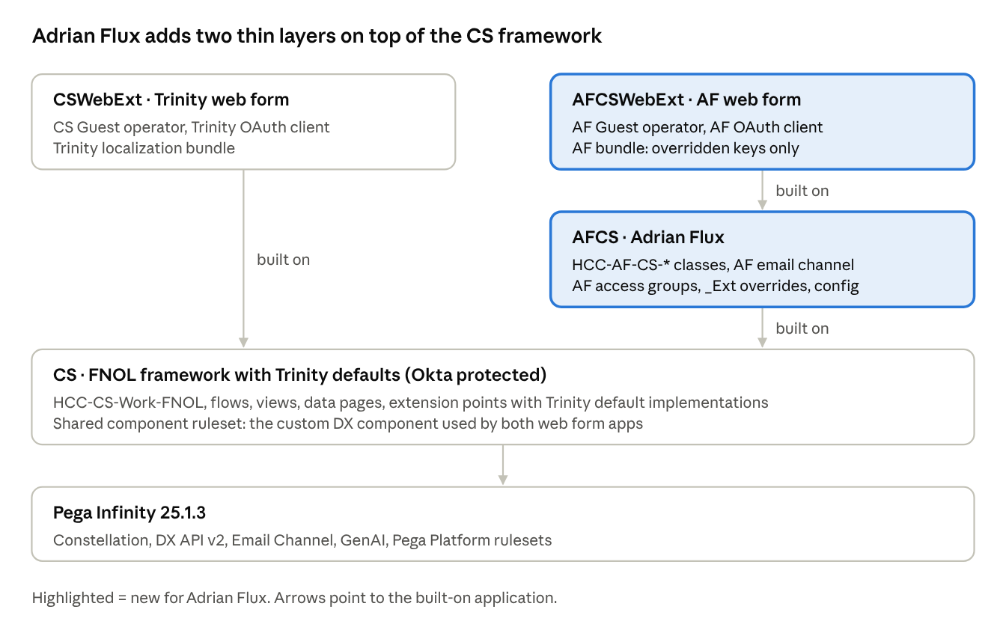
application stack · 5 layers, 2 new for AF
Read it bottom-up: each application sees everything below it, and the highest layer wins rule resolution. Okta is enforced by the authentication service and access group, not by the application, so AFCSWebExt can sit on an Okta-protected app while staying anonymous.
Application | Built on | Rulesets (own) | Purpose
CS | Pega Platform / Constellation | CS, CSInt, CSData, shared CSComponents | Framework + Trinity default implementations
CSWebExt | CS | CSWebExt | Trinity anonymous web form, Trinity bundle
AFCS | CS | AFCS, AFCSInt, AFCSData | AF classes, _Ext overrides, AF channel and config
AFCSWebExt | AFCS | AFCSWebExt | AF anonymous web form, AF bundle overrides
Ruleset guidance
- Move the custom DX component (Rule-UI-Component) into a shared component ruleset in CS so both web apps use one version. CSWebExt and AFCSWebExt then hold only bundles and app-specific settings.
- Keep integration rules (connectors, email accounts referencing data) in an Int ruleset and data instances in product rules, so they can be versioned and deployed separately.
- Lock CS ruleset versions used by AFCS; AFCS references CS:01-xx so a framework minor release is a deliberate upgrade, not a surprise.
- Each application rule lists only its own case types (HCC-AF-CS-Work-FNOL in AFCS) so the AF portal and case-creation menus do not show Trinity case types.

5. Class hierarchy, class groups and database tables
Each AF class directly inherits from its CS twin, keeps HCC-AF-CS- as its pattern parent, and maps to its own table. AF cases therefore reuse every CS rule but never share storage, IDs or work queues with Trinity.
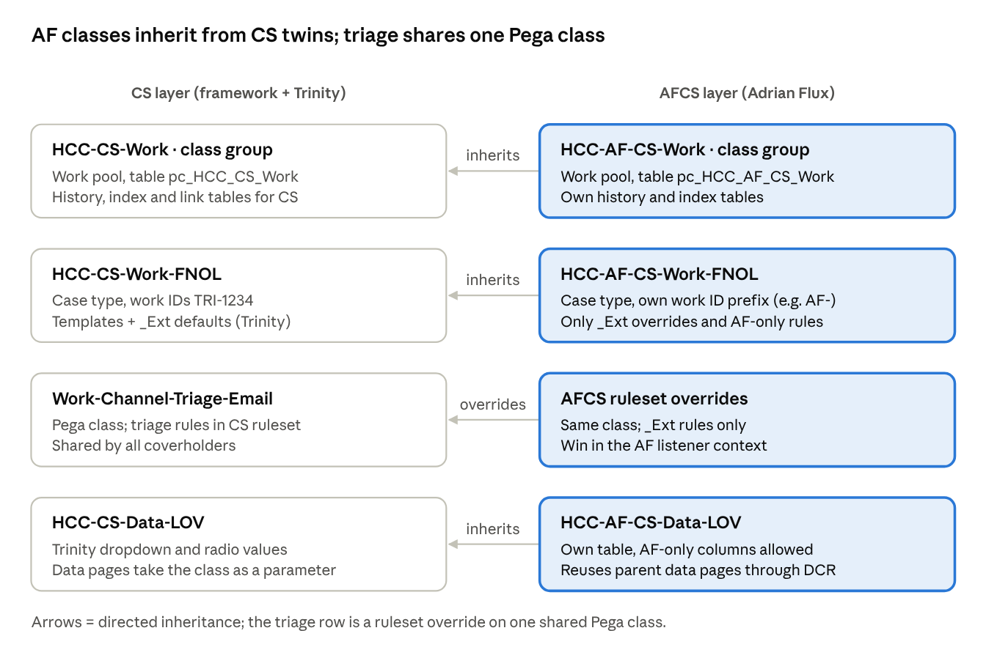
class hierarchy · 4 CS classes, 4 AF twins
Exception: email triage. Trinity has no coverholder-specific triage class; triage cases are instances of Pega's Work-Channel-Triage-Email, with its extension points saved into the CS ruleset. AF keeps this: AF triage cases are the same class, and AF differences are ruleset overrides in AFCS (section 6 and section 12). The triage row in the diagram is therefore a ruleset override, not a subclass.
Item | Trinity (CS) | Adrian Flux (AFCS) | Notes
Class group / work pool | HCC-CS-Work | HCC-AF-CS-Work | New Data-Admin-DB-ClassGroup, new work pool in the AFCS access groups
Case table | pc_HCC_CS_Work (actual name TBC) | pc_HCC_AF_CS_Work | Created by DBA from the CS DDL; same columns plus AF columns
History table | CS history table | pc_history_HCC_AF_CS_Work | Data-Admin-DB-Table mapping for History-HCC-AF-CS-Work
Work ID prefix | TRI- | AF- (TBC with business) | Set on the AF case type; subject-line parsing reads it from config
LOV data class | HCC-CS-Data-LOV | HCC-AF-CS-Data-LOV | Own table; inherits properties and data pages
Config data class | — | HCC-CS-Data-CoverholderConfig (new, in CS) | One row per coverholder; see section 6
Integration classes | HCC-CS-Int-* | HCC-AF-CS-Int-* only if AF endpoints differ | Libra and GenAI connectors usually stay in CS
Gotchas
- Properties exposed as columns in the CS table (used by duplicate check, report definitions and work queues) must be exposed again in the AFCS table. Optimizing a property is per table; inheritance does not copy columns.
- Declare indexes (Index- classes) and their tables for any embedded lists you report on.
- Attachment categories are class-scoped rules. "Photograph of Damage" inherits, but confirm the category is not circumstanced or saved only to HCC-CS-Work-FNOL with a when rule that blocks child classes.
- Work parties (pyCaseManagementDefault / work party rules) inherit; add AF-specific roles only if AF has extra parties.
- Do not reuse the CS class group for AF to "save a table". Shared tables force every report, search and purge job to filter by coverholder and make isolation a coding rule instead of a structural one.

Class naming: a coverholder layer above each application
Classes follow HCC-<Coverholder>-<App>-<Work|Data|Int>-<Name>, so AF claims classes are HCC-AF-CS-* and, in the future state, Trinity claims classes are HCC-TRI-CS-*. The extra HCC-AF- layer gives Adrian Flux a home for rules shared by any future AF application, without those applications depending on the claims app.
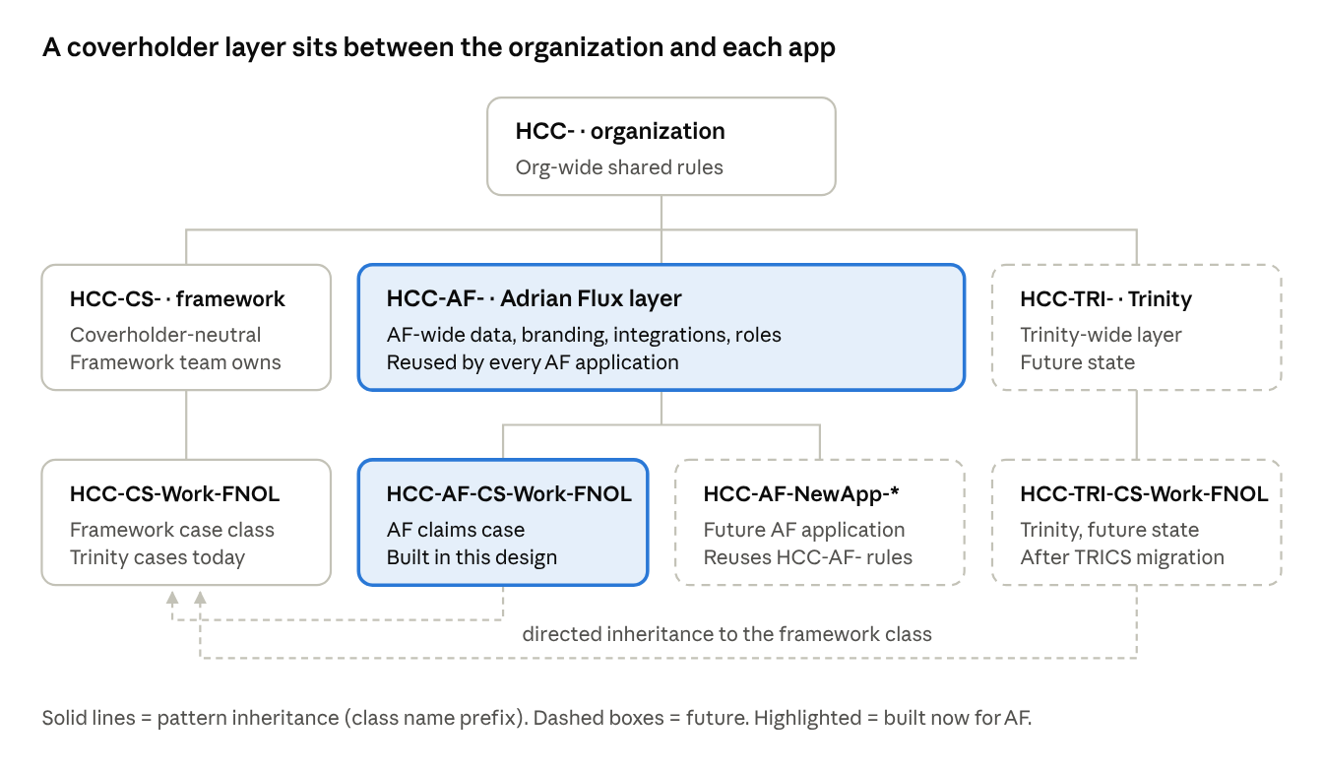
class naming · org, coverholder and application layers
Layer | Example classes | Owned by
Organization HCC- | Org-wide data and utilities | Org ruleset, if one exists
Framework HCC-CS- | HCC-CS-Work-FNOL, HCC-CS-Data-LOV, HCC-CS-Data-CoverholderConfig | CS application
Coverholder HCC-AF- | AF branding and contact data, AF integrations, AF-wide data types | A separate AF coverholder ruleset (e.g. HCCAF) that any AF application can include
Application HCC-AF-CS- | HCC-AF-CS-Work (class group), HCC-AF-CS-Work-FNOL, HCC-AF-CS-Data-LOV | AFCS application
Trinity HCC-TRI-, HCC-TRI-CS- | Same pattern, future state | TRICS (section 18)
How rule resolution works with this structure
- HCC-AF-CS-Work-FNOL has the pattern chain HCC-AF-CS-Work → HCC-AF-CS- → HCC-AF- → HCC-, and its directed parent is HCC-CS-Work-FNOL.
- Pega searches the pattern chain before the directed parent. A rule in HCC-AF- therefore beats a framework rule of the same name in HCC-CS-Work-FNOL. Only put rules in HCC-AF- that are meant to apply to every AF application, and avoid accidental name clashes with framework rules.
- Keep AF claims behaviour (_Ext overrides, case type, views) in HCC-AF-CS-*, not in HCC-AF-.
Other implications
- Application names follow the same coverholder-first order as the classes: AFCS and AFCSWebExt for Adrian Flux, TRICS and TRICSWebExt for Trinity in the future state, <XX>CS and <XX>CSWebExt for any new coverholder. Add the AF coverholder ruleset to the AFCS application so HCC-AF- rules are available.
- Class group HCC-AF-CS-Work maps to pc_HCC_AF_CS_Work. Check table names against your database's name-length limit and Pega's class-name length limit before fixing them, as the extra segment adds length.
- Trinity's existing HCC-CS-Work-FNOL cases stay where they are. The HCC-TRI- layer can be created earlier for Trinity-wide data, and HCC-TRI-CS-* applies when Trinity moves to TRICS (section 18).
- Use the same convention for every new coverholder: HCC-<XX>- and HCC-<XX>-CS-*.

6. Dynamic Class Referencing and coverholder configuration
Resolve a coverholder code first, then read every class name and coverholder value from one configuration data page. Interactive requests get the code from the application context; anything working on a case gets it from the case.
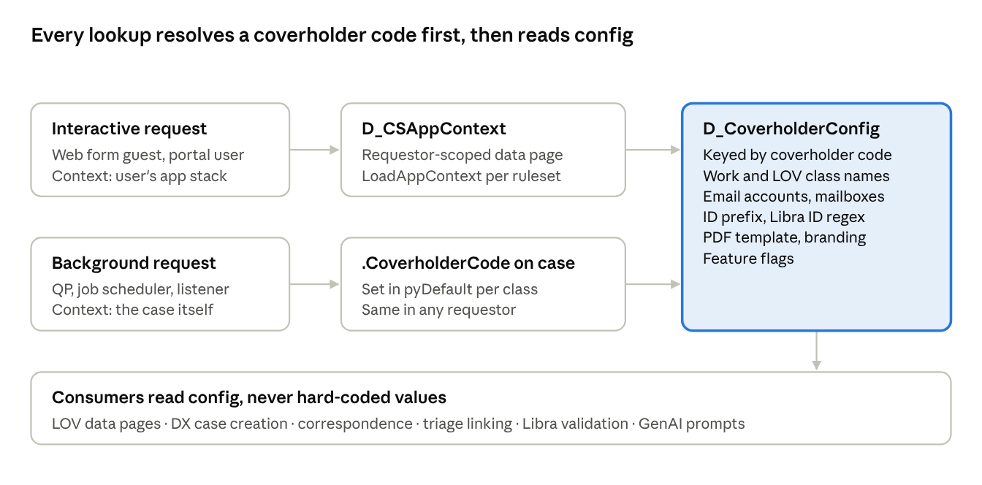
DCR resolution · 2 contexts, 1 config
The two paths exist because background requestors (queue processors, job schedulers, email listeners) do not run in the claimant's or claim handler's application context. A DCR value taken from the requestor would be wrong, or Trinity, for AF cases processed in the background.

Building blocks
Rule / instance | Class | Layer | Content
D_CSAppContext (requestor, read-only) | HCC-CS-Data-AppContext | CS | Coverholder code + class names for the current app
LoadAppContext data transform | HCC-CS-Data-AppContext | CS ruleset = Trinity values; AFCS ruleset = AF values | Same class, same name; ruleset order in the app stack picks the AF version
HCC-CS-Data-CoverholderConfig data type + table | HCC-CS-Data-CoverholderConfig | CS | One row per coverholder (TRI, AF): classes, email accounts, mailboxes, prefixes, regex, template names, flags
D_CoverholderConfig (node, keyed by CoverholderCode) | same | CS | Cached lookup; refresh on table change
.CoverholderCode property | HCC-CS-Work | CS | Set by pyDefault of each case class (TRI in CS, AF in AFCS)
GetCoverholderCode function or when-backed data transform | HCC-CS-Work | CS | Returns .CoverholderCode on a case, else D_CSAppContext.CoverholderCode
The LoadAppContext override is the only ruleset-level override in this design, and it is safe because it is used only in interactive, app-aware requests.

How rules use it
- Creating a page or case: Page-New or the create-case step with ClassName = D_CoverholderConfig[CoverholderCode:<code>].FNOLWorkClass.
- Report definitions: call pxRetrieveReportData with ClassName from config. The report definition exists on HCC-CS-Data-LOV and is inherited by HCC-AF-CS-Data-LOV, so one name works for both.
- Data pages: add CoverholderCode as a parameter to every coverholder-sensitive data page, even when the class alone would differ. Node-scoped pages are cached by parameter values, so the parameter keeps Trinity and AF caches apart.
- DX component: the component calls a data page (for example D_WebFormBootstrap) through PCore.getDataPageUtils(). The server resolves the coverholder from the guest's app; the component never sends or stores a class name.
- Polymorphism first: on a case, prefer calling the rule by name and letting class inheritance pick the AF version. Use DCR only for things class resolution cannot reach: data classes, data instances (email accounts, listeners) and values.
Do not branch on the code (when CoverholderCode = AF) inside framework rules. The code selects configuration or a class; behaviour differences go into _Ext rules on the AF class.

Pega-owned classes: specialization by ruleset
Yes, customizations on Pega-owned classes such as Work-Channel-Triage-Email can be differentiated by ruleset. Rule resolution searches the requestor's ruleset list top-down, so a rule of the same class and name in the AFCS ruleset wins whenever the requestor runs in AFCS context; in CS context the CS version runs.
What you are changing | Mechanism | Example
Rules on classes you own (HCC-*) | Class specialization: override on the AF class | DuplicateCheckCriteria_Ext on HCC-AF-CS-Work-FNOL
Rules on Pega-owned classes (Work-Channel-Triage-Email, Work-, Data-, @baseclass) | Ruleset specialization: same class and name, saved in the AFCS ruleset | Triage AI _Ext rules on Work-Channel-Triage-Email in AFCS
Values (mailboxes, prompt names, patterns, thresholds) | Configuration: D_CoverholderConfig | AF reply mailbox, AF extraction prompt name
Conditions that make ruleset specialization safe
- The requestor must be in the right context. For the email channel this holds: each channel's service package has its own access group (CS vs AFCS:Background), so the listener and every rule run in that requestor resolve correctly.
- Follow-on work must keep that context. Queue processors, SLAs and deferred steps started from triage must run with a AFCS access group. Class polymorphism cannot rescue a wrong context here, because both coverholders' triage cases are the same class.
- Stamp the coverholder on the triage case at creation (.CoverholderCode from D_CSAppContext in the listener requestor), so later processing and access rules can read it from the case.
- CS-ruleset overrides of Pega extension points are framework templates. Because AFCS is built on CS, every CS override of a Pega extension point also runs for AF unless AFCS overrides it. So the CS version must hold no Trinity specifics: it is a template that calls _Ext rules, with Trinity behaviour in the CS _Ext defaults. AFCS overrides only the _Ext rules, never the template.
- Move logic to owned classes where you can. Where a Pega extension point is on Work- but only matters for FNOL, call an _Ext rule on HCC-CS-Work or HCC-CS-Work-FNOL from it, so AF can specialize by class instead of by ruleset.
- Make overrides visible. Ruleset overrides do not appear in the class hierarchy. List every one in the extension catalogue (section 13) and keep the AFCS ruleset's overrides of Pega classes to _Ext rules only.
Optional to evaluate: if your Pega version lets an email channel use an application-specific triage case type derived from Work-Channel-Triage-Email, that would give class-level separation and its own table. It is not required for this design.

7. Security: operators, access groups, roles and SSO
AF gets its own access groups, roles and operators so that an AF user or guest can never open, list or create a Trinity case, and vice versa. Isolation rests on separate classes and tables plus Access Role to Object (ARO) rules, not on UI hiding.
Access group | Application | Users | Key roles / notes
AFCSWebExt:Guest | AFCSWebExt | AF web form technical operator (AF Guest User) | Create HCC-AF-CS-Work-FNOL via DX API, read web form data pages, upload attachments; no open, list or search
AFCS:ClaimHandler | AFCS | AF claim handlers (Okta) | Work on HCC-AF-CS-Work-*; AF work queues only
AFCS:Supervisor | AFCS | AF team leads | As above + reassign, reports, config table edit if agreed
AFCS:Background | AFCS | AF queue processors, job schedulers, email listener service package | Least privilege for automated steps
AFCS:Admin | AFCS | AF config owners | Edit HCC-AF-CS-Data-LOV and AF config rows via delegated rules
Role design
- Create AF access roles (HCC:AFCSClaimHandler etc.) that depend on the CS roles, then add ARO entries for the HCC-AF-CS- classes.
- Do not grant AF roles any ARO on HCC-CS-Work-FNOL beyond what rule execution needs, and keep CS roles out of AF access groups. Test explicitly that an AF handler gets "access denied" on a TRI- case opened by URL or DX API, and the reverse.
- If AF and Trinity handlers can ever be the same person, give one operator two access groups and switch application, rather than one access group spanning both.
- Guest operators: one per web app (CS Guest User, AF Guest User), each with its own OAuth 2.0 client registration and access group. Never share a guest operator across coverholders. Triage cases of both coverholders share the Work-Channel-Triage-Email class and table, so class-level ARO cannot separate them: restrict them with an Access When (or access control policy) on .CoverholderCode and with coverholder-specific work queues.
Okta / SSO mapping
- Reuse the existing CS authentication service if it maps users by Okta group. Add an Okta group (for example pega-afcs-claimhandler) mapped to AFCS:ClaimHandler through the operator provisioning data transform.
- If the business wants a separate AF Okta app or login URL, create a second authentication service with its own alias; the rest of this design is unaffected.
Web form hardening (anonymous channel)
- Restrict CORS on the AF OAuth client and DX API to the AF web form host.
- Add rate limiting and bot protection (CAPTCHA) on submit; the guest is anonymous.
- Validate every field server-side with the same regex as the bundle, held in AF config. Client-side validation is a convenience only.
- Scan uploads (type allow-list, size limit, malware scan) before AI image analysis runs.
- Mask or exclude personal data from logs and from the DX response returned to the browser.

8. Web form channel: AFCSWebExt, DX API and the custom component
AF reuses the same custom DX component unchanged; only the app it is published in, the bundle keys it reads and the configuration it bootstraps from differ. The component must therefore be fully configuration-driven before AF starts.
Refactor the component once (CS layer)
- Remove every hard-coded value: case type ID, class names, coverholder name, logo, URLs, phone numbers, regex. Read them from a bootstrap data page (D_WebFormBootstrap) and the localization bundle.
- Create the case with caseTypeID from the bootstrap page (HCC-AF-CS-Work-FNOL for AF).
- Load dropdown and radio values through PCore.getDataPageUtils() on the shared LOV data pages (section 9); the server picks the LOV class.
- Load labels, placeholders, tooltips and errors from the bundle with the same keys in both apps; AF overrides only the values.
- Keep visual theme (colours, fonts, logo) in bundle or theme settings, not in component code, so AF branding needs no build.
- Publish the component into the shared component ruleset so both apps run one version.
AFCSWebExt set-up
Item | Action
Application rule | AFCSWebExt, built on AFCS; ruleset AFCSWebExt:01-01
Operator | AF Guest User, access group AFCSWebExt:Guest
OAuth 2.0 client registration | New client for the AF web form; grant type as used by CSWebExt today; CORS restricted to the AF host
Localization bundle | Save As the CSWebExt bundle into AFCSWebExt; keep identical keys, change AF values; add keys only for AF-only fields
Bootstrap data page values | Coverholder code AF, case type ID, enabled sections, max upload size, allowed file types
Validation patterns | Held in D_CoverholderConfig or the AF bundle; the same pattern is re-checked server-side by an edit-validate rule on HCC-AF-CS-Work-FNOL
Hosting | AF web page embeds the component with the AF OAuth client ID and Pega URL
Bundle governance
- Treat bundle keys as an interface: a new key is added to CSWebExt first (with a Trinity value), then to AFCSWebExt. A missing AF key falls back silently, so add an automated key-parity check to the pipeline.
- If AF needs a field Trinity does not have, add it to the component as an optional, config-enabled field rather than forking the component.
- Languages: if AF needs Welsh or another locale, add locale variants to the AF bundle only.
Case creation call
The DX API create request runs as AF Guest User, so its application context is AFCSWebExt → AFCS → CS. pyDefault on HCC-AF-CS-Work-FNOL sets .CoverholderCode = AF; NewDefaults then runs the AF duplicate-check extension (section 10). Attachments uploaded in the form are posted with the AF attachment categories, which inherit from CS.

9. LOV data type and data pages
HCC-AF-CS-Data-LOV inherits all properties, keys, report definitions and data pages from HCC-CS-Data-LOV and stores AF values in its own table. The existing data pages stay the single entry point; they gain a CoverholderCode parameter and read from the class that config names.
Set-up steps
- Create HCC-AF-CS-Data-LOV (concrete, directed parent HCC-CS-Data-LOV, same keys, e.g. ListType + Code).
- Map it to a new table through Data-Admin-DB-Table; create the table with the same columns as the CS LOV table.
- Add AF-only properties to the AF class only, and expose them as columns in the AF table.
- Load AF values with the data import wizard or a migration data set; keep the CSV in the AFCS product rule for repeatable deployment.
- Add HCC-AF-CS-Data-LOV to the AFCS application's data types so business users can maintain it in App Studio.
Data page pattern
Data page | Scope | Parameters | Source
D_LOVList | Node | CoverholderCode, ListType, optional ParentCode (for dependent dropdowns) | Data transform that calls pxRetrieveReportData with ClassName = D_CoverholderConfig[CoverholderCode].LOVClass and the inherited report definition
D_LOV (single record) | Node | CoverholderCode, ListType, Code | Lookup with class from config, or filter of D_LOVList
- Callers on a case pass .CoverholderCode; the web form and portal pass D_CSAppContext.CoverholderCode (the bootstrap page can do this so the component never sends it).
- If a dropdown is identical for both coverholders, either copy the rows to the AF table or add an InheritFromCS flag in config that makes the AF source a union of both tables. Copying is simpler and keeps AF independent; prefer it unless the lists are large and change often.
- Keep the response shape identical across coverholders (same pxResults properties) so the DX component binds the same fields.
- Refresh strategy: node-scope with reload on table save, or a short refresh interval; LOV edits must not need a restart.
Apply the same pattern to the other CS data tables that drive the web form or validation rules (for example postcode rules, peril lists, document categories): AF class, own table, shared data page, class from config.

10. Case type, NewDefaults and duplicate check
The AF case type gets its own case type rule, but every process, flow action, view and step it calls is inherited from CS. NewDefaults stays a single CS template; AF overrides only the small extension rules it calls.
Case type
- Create HCC-AF-CS-Work-FNOL as a case type in AFCS with its own pyDefault case type rule. Stages and steps are stored in that rule, so it is the one accepted copy in this design.
- Keep the case type rule thin: each step calls a CS process by name. Rule resolution then runs the CS process for AF cases, and the AF class can override any single process, flow action or view.
- Set AF-specific items on the case type: work ID prefix, SLAs (if different), attachment categories shown, case-wide supporting views, pyDefault data transform that sets .CoverholderCode = AF.
- Keep a stage-structure checklist: if a stage is added in CS, the AF case type rule must be updated in the same release. Add a unit test that compares the two stage lists.
Refactor NewDefaults into template + extensions (CS)
Rule | Class | Layer | Role
NewDefaults (activity, existing) | HCC-CS-Work-FNOL | CS | Template: sets common defaults, calls the steps below in order; no coverholder logic
DuplicateCheckCriteria_Ext (data transform) | HCC-CS-Work-FNOL | CS default = Trinity fields; AFCS override | Builds the match criteria (e.g. policy number, loss date, claimant, vehicle reg)
D_DuplicateCandidates (data page, parameterized) | HCC-CS-Work-FNOL | CS | Runs the duplicate report definition in the case's own class, so AF searches only the AF table
IsDuplicate_Ext (when or decision table) | HCC-CS-Work-FNOL | CS default; AFCS override | Decides match rules, tolerances (e.g. loss date ± N days)
OnDuplicateFound_Ext (data transform) | HCC-CS-Work-FNOL | CS default; AFCS override | Sets .IsPotentialDuplicate, .DuplicateOfID, routes or flags
NewDefaults_Ext (activity, empty) | HCC-CS-Work-FNOL | CS empty; AFCS optional | Any other AF-only defaults
Do not Save As the whole NewDefaults into HCC-AF-CS-Work-FNOL. A full copy stops receiving CS fixes and doubles regression effort.
Duplicate-check guidelines
- Expose every match property as a column in the AF case table and index it; the check runs synchronously inside the DX create call.
- Never reveal a duplicate to the anonymous claimant (no other claim ID or details in the DX response). Flag it on the case and let the claim handler decide.
- Consider Pega's OOTB duplicate-search step (weighted conditions on the case type) for AF if its rules are simpler than Trinity's; it is configured per case type, so it fits class specialization naturally.
- Unit-test the AF match rules with PegaUnit test cases on IsDuplicate_Ext.

11. Correspondence, PDF generation and AI image analysis
All three capabilities are reused as framework steps; AF supplies templates, branding, sender account and, if needed, AI thresholds through overrides and config.
Confirmation email (claimant and/or policy holder)
- Keep the Send Email step and recipient logic in CS. Read the sender email account name from D_CoverholderConfig.OutboundEmailAccount, not a literal account name.
- Create AF correspondence rules (ClaimConfirmation) on HCC-AF-CS-Work-FNOL with the same names as CS. Class resolution then picks AF wording for AF cases.
- Split templates into shared paragraphs (claim details table) and coverholder paragraphs (greeting, legal footer, contact details, logo), so AF overrides only the coverholder paragraphs.
- Recipient rule (claimant, policy holder or both) is a decision table ConfirmationRecipients_Ext with a CS default and optional AF override.
Claim summary PDF
- Keep generation (the existing Create PDF step or pxCreatePDF call, the attachment category and the file name pattern) in CS.
- Override only the PDF section or view on HCC-AF-CS-Work-FNOL for layout and branding; keep a shared claim-details section embedded in both.
- Read the file name prefix and attachment category from config so the PDF is named, for example, AF-1234_ClaimSummary.pdf.
- Check fonts and images used by the AF template are embedded in the AF ruleset (binary file rules), not linked externally.
AI image analysis ("Photograph of Damage")
- Reuse the CS trigger (attachment category check), queue processor and GenAI or vision connector. The analysis runs once per photo, for one or many photos.
- Run AF items on a AFCS-context queue processor (section 14), or make sure the shared processor opens the case and resolves everything from the case class and .CoverholderCode.
- If AF needs different prompts, damage categories or confidence thresholds, put the prompt text and thresholds in config or an ImageAnalysisPrompt_Ext rule on the AF class; never branch inside the framework activity.
- Confirm with AF and the data-protection lead that sending AF claimant photos to the AI service is covered by AF's privacy notice and data-processing terms.
- Store results in the same embedded structure as Trinity so the shared review tab renders them.

12. End-to-end flow: email channel, validation loop, triage and Libra
AF-specific work concentrates at the edges: the web form, the outbound validation email and the inbound email channel. The case core in the middle (duplicate check, PDF, AI analysis, parsing, review, Libra, resolution) is reused, with small extension overrides.
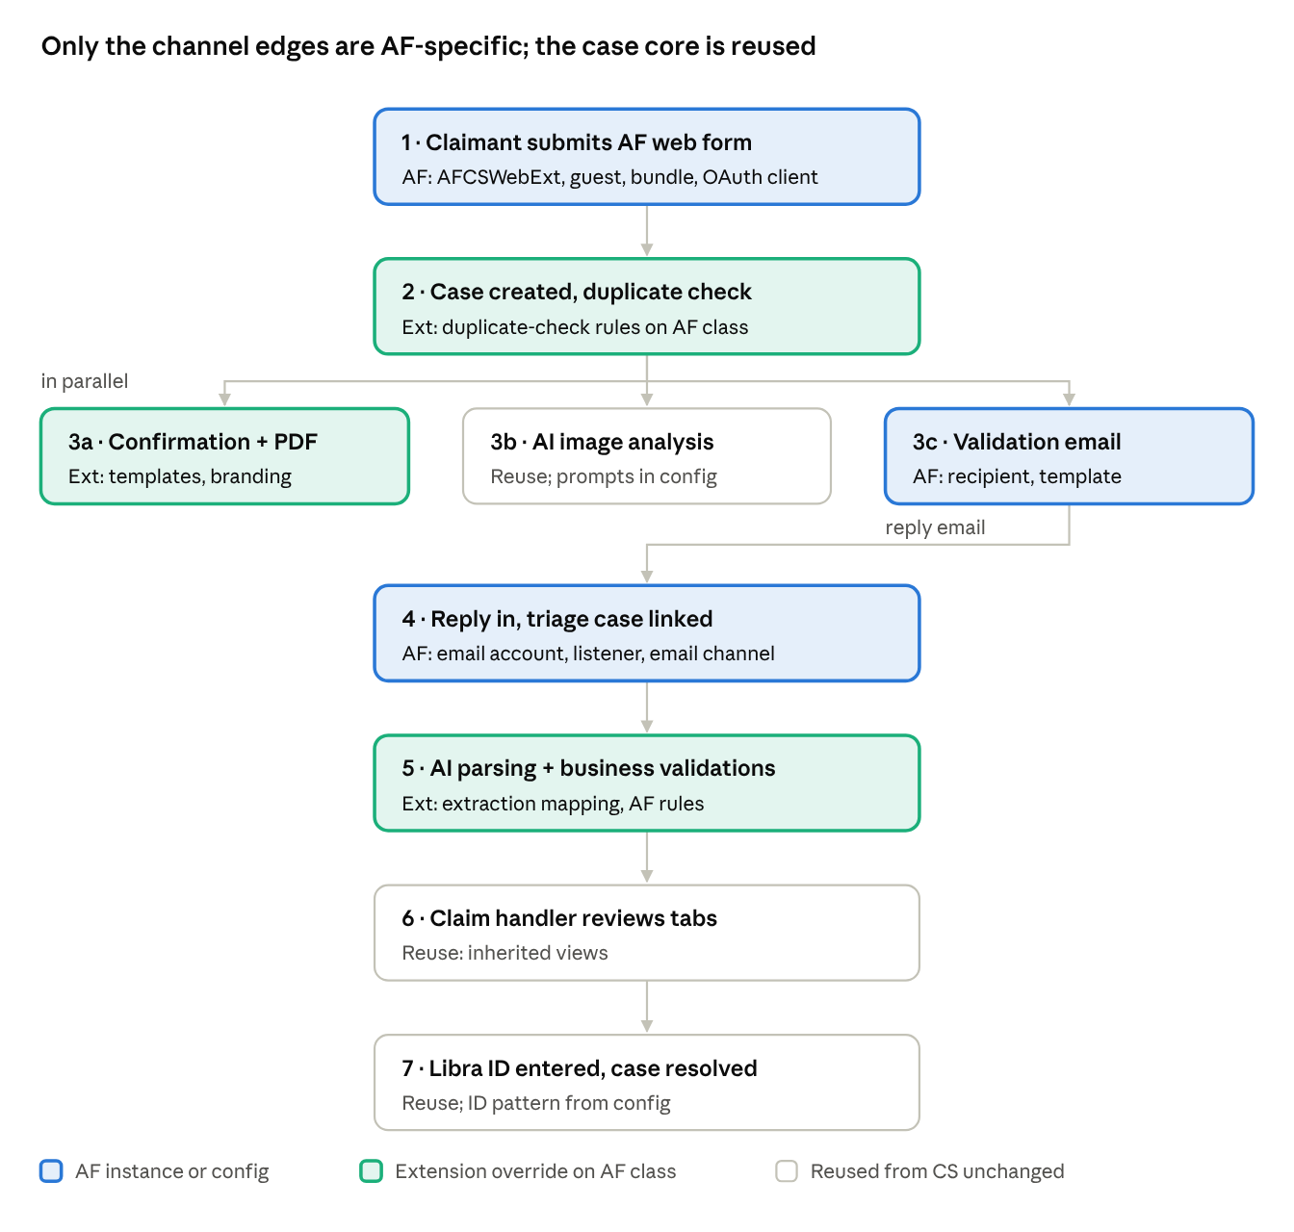
AF end-to-end flow · 7 steps, 3 kinds of change
Replies from the AF validation team arrive only through the AF channel, so the triage case and every rule it runs resolve in the AFCS context.

Inbound email channel set-up (AF)
Instance / rule | AF item | Notes
Email account (Data-EmailAccount) | AFCS_Inbound (and AFCS_Outbound if a separate sender) | OAuth 2.0 / modern auth to the AF mailbox; secrets in an authentication profile or keystore, never in rule text
Email channel | AFCS Policy Validation channel | Created in App Studio in AFCS; triage cases stay Work-Channel-Triage-Email, as for Trinity; generates its listener and service email rule
Email listener (Data-Admin-Connect-EmailListener) | Generated, AF mailbox | Polling interval, folder, processed-mail folder; run on the background node type
Service email rule + service package | Generated; service package access group AFCS:Background | This access group puts the listener in AFCS context, so AF rules and config resolve correctly
Subject parsing | Pattern from D_CoverholderConfig.CaseIDPattern (e.g. AF-[0-9]+) | Shared CS rule; AF only changes the pattern
Text analytics / NLP model | Reuse the CS model if the AF reply format is similar; otherwise an AF model in AFCS | Entity extraction for policy number, cover dates, previous claims

Triage AI processing on Work-Channel-Triage-Email
Today the Trinity reply processing (AI classification, entity extraction, attachment parsing) lives in Pega extension points of Work-Channel-Triage-Email, saved in the CS ruleset. Modularize it once in CS, then AF overrides only small _Ext rules of the same class in the AFCS ruleset.
Refactoring steps (CS ruleset)
- List every rule of Work-Channel-Triage-Email (and Work-Channel-Triage, Work-Channel if used) that exists in the CS ruleset, with the Pega extension point it overrides.
- In each, keep only the generic sequence and move each Trinity-specific step, unchanged, into an _Ext rule of the same class in the CS ruleset.
- Replace hard-coded values (Trinity mailbox, TRI- pattern, prompt names, document types) with D_CoverholderConfig[.CoverholderCode] lookups.
- Push FNOL-specific work out of triage: triage links the case and extracts raw data; mapping onto the claim and business validations run on the FNOL case class, where AF specializes by class.
- Run Trinity regression: replies must be classified, linked and parsed exactly as before.
Proposed triage extension points (class Work-Channel-Triage-Email)
Extension rule | Type | CS ruleset default (Trinity) | AFCS ruleset override
SetTriageCoverholder | Data transform, called at triage creation | Sets .CoverholderCode from D_CSAppContext | None needed: the context already returns AF
ResolveCaseFromSubject_Ext | Data transform | Extracts ID with the config pattern and opens the FNOL case | Rarely
ClassifyReply_Ext | Data transform / text analyzer call | Trinity NLP model or GenAI prompt: policy schedule received, information missing, decline | If AF reply wording or intents differ
ExtractReplyEntities_Ext | Data transform / GenAI prompt | Trinity entity list: policy number, cover dates, previous claims | AF entity list or prompt name from config
ProcessReplyAttachments_Ext | Activity / data transform | Trinity document types: policy schedule, claims history | AF document types and parsing prompts
HandOverToFNOL_Ext | Data transform | Copies extracted raw data to the FNOL case, then the FNOL case runs MapParsedPolicyData_Ext and ApplyPolicyValidations_Ext | Rarely; AF differences sit on HCC-AF-CS-Work-FNOL
OnTriageException_Ext | Router / data transform | Trinity exception work queue | AF exception work queue
Triage-specific checks
- Expose .CoverholderCode as a column of the triage table; use it in triage reports, work queue filters and access rules, because both coverholders share the class and table.
- Any queue processor or job scheduler started from triage (for example GenAI attachment parsing) runs with AFCS:Background for AF items, or as a separate AF processor.
- A claim handler opening a triage case runs their own application's ruleset list. AF handlers must only have AFCS access groups, so they always see AF triage behaviour.
- If AF replies are expected to look the same as Trinity's, start with no AFCS triage overrides at all and add _Ext overrides only where AF tests fail.
Linking and parsing
- The triage case reads the case ID from the subject, opens the AF FNOL case, attaches the email body and attachments (policy schedule, previous-claims history) and resolves or routes.
- No match, or a Trinity-format ID arriving in the AF mailbox, goes to an AF exception work queue, never to Trinity.
- GenAI document parsing reuses the CS connector. AF-specific field mapping (MapParsedPolicyData_Ext) and business validations (ApplyPolicyValidations_Ext, decision tables) are overrides on HCC-AF-CS-Work-FNOL.
- Store parsed results in the same CS data structure so the inherited review tabs render without change; add an AF view override only for AF-only fields.
Outbound validation email
- Recipient mailbox, subject format (must contain the case ID in the pattern the listener parses) and template come from AF config and AF correspondence rules.
- If Trinity has a wait step or SLA for the reply with chasers and escalation, reuse it with AF durations from config.
Libra ID and resolution
- Reuse the CS flow action and resolve step. Validate the Libra ID format with a pattern from config, so a different AF ID format needs only a config row.
- Confirm with AF whether Libra uses a separate AF book or entity code; if so, show it on the AF view and store it on the case.

13. Extension point catalogue
These are the extension points the CS layer must expose before AF development starts. Each is defined on the CS class with the Trinity behaviour as default; AF overrides on the AF class with the same name. Names are proposals; align them with your naming standards.
Area | Extension rule | Type | Defined on | CS default | AF override expected?
Coverholder context | LoadAppContext | Data transform | HCC-CS-Data-AppContext | Trinity code and classes | Yes (AFCS ruleset)
Case defaults | pyDefault (case type) | Data transform | HCC-CS-Work-FNOL | Sets CoverholderCode = TRI | Yes
Case creation | NewDefaults_Ext | Activity | HCC-CS-Work-FNOL | Empty | Optional
Duplicate check | DuplicateCheckCriteria_Ext | Data transform | HCC-CS-Work-FNOL | Trinity match fields | Yes
Duplicate check | IsDuplicate_Ext | When / decision table | HCC-CS-Work-FNOL | Trinity rules | Yes
Duplicate check | OnDuplicateFound_Ext | Data transform | HCC-CS-Work-FNOL | Flag + route | Optional
Validation | ValidateClaimSubmission_Ext | Edit validate / validate rule | HCC-CS-Work-FNOL | Trinity field checks | Yes
Correspondence | ClaimConfirmation (+ paragraphs) | Correspondence | HCC-CS-Work-FNOL | Trinity wording | Yes
Correspondence | ConfirmationRecipients_Ext | Decision table | HCC-CS-Work-FNOL | Claimant and/or policy holder rules | Optional
PDF | ClaimSummaryPDF | Section / view | HCC-CS-Work-FNOL | Trinity layout | Yes (branding)
AI image analysis | ImageAnalysisPrompt_Ext | Data transform / prompt | HCC-CS-Work-FNOL | Trinity prompt | Optional
Validation email | PolicyValidationRequest | Correspondence | HCC-CS-Work-FNOL | Trinity template | Yes
Triage linking | ResolveCaseFromSubject_Ext | Data transform | Work-Channel-Triage-Email (CS ruleset; AF override in AFCS ruleset) | Uses config pattern | Rarely
Parsing | MapParsedPolicyData_Ext | Data transform | HCC-CS-Work-FNOL | Trinity reply mapping | Yes if reply format differs
Business validations | ApplyPolicyValidations_Ext | Decision table / when set | HCC-CS-Work-FNOL | Trinity rules | Yes
Review UI | Review tab views | View | HCC-CS-Work-FNOL | Trinity layout | Only for AF-only fields
Routing | RouteToClaimHandler_Ext | Router / decision table | HCC-CS-Work-FNOL | Trinity work queues | Yes (AF queues)
Libra | ValidateLibraID_Ext | Edit validate | HCC-CS-Work-FNOL | Pattern from config | Rarely
How to create an extension point (refactoring rule)
- Find the Trinity-specific step inside a CS rule.
- Move it, unchanged, into a new rule named <Purpose>_Ext on the same CS class. Mark it as an extension point in its description and usage notes so developers and Dev Studio searches find it.
- Replace the step with a call to the new rule. Run the Trinity regression suite: behaviour must not change.
- Document the extension in this table: purpose, inputs, outputs and the default.

14. Background processing, SLAs, routing, reporting and search
Every automated requestor that touches AF cases must run in AFCS context or resolve purely from the case. This is the area most often missed when a second coverholder is added, because nothing fails visibly: AF cases just pick up Trinity behaviour.
Queue processors and job schedulers
- List every queue processor, job scheduler, agent and SLA activity used by the FNOL flow (AI image analysis, PDF generation, email sending, chasers, purge/archive).
- For each, either create an AF instance with access group AFCS:Background, or prove that it only opens the case and calls rules by name on the case (class resolution then works), with no app-context DCR inside.
- Prefer separate dedicated queue processors per coverholder for heavy work (AI analysis): separate throughput, separate failure handling, and AF volumes cannot delay Trinity.
- Broken-queue monitoring and retry settings: copy Trinity's values, then tune from AF volumes.
SLAs and routing
- SLA rules are class-based and inherit. Override only those with AF-specific goals or deadlines, or read durations from config.
- Create AF work queues (for example AFCS_FNOL_Review, AFCS_Exceptions) in the AF work group and route through RouteToClaimHandler_Ext. Never route AF assignments to Trinity work queues.
- Assignment tables are shared platform tables, so isolation depends on work queue and access-group design; test that an AF handler's worklist and queues show no TRI- work.
Reporting and MI
- Report definitions on HCC-CS-Work-FNOL inherit to AF and, when run in the AF class, read the AF table. Business users in each app see only their coverholder.
- A cross-coverholder MI view (Trinity + AF) needs a deliberate design: a BIX extract or data warehouse feed per table, or a report that joins both class groups, owned by the MI team and restricted to an MI role.
- Add CoverholderCode to every extract so downstream reporting can split by coverholder.
Search, retention and archiving
- Add HCC-AF-CS-Work classes to search indexing configuration (custom search properties, if Trinity uses them).
- Configure case archiving and purge policies for the AF case type separately; AF retention periods may differ contractually.
- Include the AF triage cases and attachments in retention rules.

15. DevOps, packaging, testing and regression governance
Because AF inherits from CS, every CS change is an AF change. The pipeline must therefore run both Trinity and AF regression on any CS-layer change, and AF-only changes must never touch CS rulesets.
Branching and ownership
- Branches are per application layer: CS-layer refactoring branches are merged in CS by the framework team; AF branches are created in AFCS or AFCSWebExt.
- A pull-request rule: any branch that touches a CS ruleset needs approval from the framework owner and a green Trinity + AF regression run.
Packaging (product rules)
Product rule | Contents
CS_Framework | CS rulesets incl. refactored extension points, shared component ruleset, HCC-CS-Data-CoverholderConfig class and Trinity config row
CSWebExt | CSWebExt ruleset, Trinity bundle, CS Guest operator, Trinity OAuth client
AFCS | AFCS rulesets, AF class definitions, DB table mappings, AF access groups and roles, work groups and queues, email accounts, email channel, listener, service package, AF config row, AF LOV data
AFCSWebExt | AFCSWebExt ruleset, AF bundle, AF Guest operator, AF OAuth client
- Keep environment-specific values (mailbox addresses, endpoints, OAuth secrets) out of product rules; set them per environment through dynamic system settings, application settings or the deployment pipeline.
- DB DDL for the AF tables (case, history, index, LOV) is delivered as a DBA script and run before the first AFCS deployment.
- Deploy order: CS_Framework → CSWebExt (Trinity regression) → AFCS → AFCSWebExt.
Testing
Level | What | Tool
Unit | Each _Ext rule (CS default and AF override), LoadAppContext, config lookups, subject-ID parsing, Libra ID pattern | PegaUnit test cases
Contract | DX API create for both guest operators: correct class, ID prefix, coverholder code; bundle key parity | API tests in the pipeline
Scenario | Full flow per coverholder: submit → duplicate → emails → AI → validation reply → triage → Libra → resolve | Pega scenario tests / automation suite
Isolation | AF users cannot open, list or search TRI cases and vice versa; AF reply in Trinity mailbox goes to exceptions | Security test pack
Background context | AF items processed by queue processors and listener use AF templates, accounts and rules | Scenario tests with log assertions
Performance | Duplicate check and DX create under peak AF volume; AI queue throughput | Load test
Run the Trinity scenario suite before and after the CS refactoring (Phase 0); the result must be identical before any AF work is merged.

16. Implementation plan and coverholder onboarding checklist
Deliver in five phases; Phase 0 changes only CS and must ship with zero Trinity behaviour change before AF work merges.
- Phase 0 – Make CS a framework (CS layer only)
  - Complete the capability inventory (section 2) and agree the extension point list (section 13).
  - Create HCC-CS-Data-CoverholderConfig, D_CoverholderConfig, HCC-CS-Data-AppContext, D_CSAppContext, LoadAppContext; add .CoverholderCode to HCC-CS-Work and set it to TRI in pyDefault; backfill existing Trinity cases.
  - Replace hard-coded classes, accounts, prefixes and patterns with config lookups.
  - Refactor NewDefaults, correspondence, PDF, parsing and validations into templates + _Ext rules.
  - Make the DX component configuration-driven and move it to the shared component ruleset.
  - Parameterize LOV and other data pages with CoverholderCode.
  - Run Trinity regression; release CS.
- Phase 1 – AF foundation (AFCS)
  - Create the AFCS application built on CS, rulesets, class group, classes, DB tables and mappings.
  - Create the AF case type with thin stages calling CS processes; set work ID prefix and pyDefault.
  - Add the AF config row, LoadAppContext AF override, access groups, roles, work groups and queues, Okta group mapping.
- Phase 2 – AF web form (AFCSWebExt)
  - Create AFCSWebExt built on AFCS, AF Guest operator, OAuth client, AF bundle, AF LOV data.
  - Contract-test DX create and the full form against the AF host.
- Phase 3 – AF specializations
  - Duplicate check, correspondence, PDF branding, validation email, parsing map and business rules as _Ext overrides.
  - AF email accounts, email channel, listener, service package; AF queue processors and job schedulers.
- Phase 4 – Test, harden and go live
  - Scenario, isolation, background-context and performance tests; security review of the anonymous channel.
  - Deploy in order; smoke test both coverholders in production; hypercare.

Onboarding checklist (reuse for every new coverholder)
- ☐ Coverholder code, case ID prefix and Libra entity agreed
- ☐ Application <XX>CS built on CS; <XX>CSWebExt built on <XX>CS
- ☐ Class group HCC-<XX>-CS-Work, case and data classes with directed parents in CS; coverholder layer HCC-<XX>- with its own coverholder ruleset
- ☐ DB tables for case, history, index and data classes created; exposed columns match CS
- ☐ Data classes (LOV and other tables) with own tables and data loaded
- ☐ Config row in HCC-CS-Data-CoverholderConfig; LoadAppContext override
- ☐ Case type with work ID prefix, pyDefault sets coverholder code
- ☐ Access groups, roles, AROs, work groups, work queues, Okta mapping
- ☐ Guest operator, OAuth client, CORS, bundle, branding
- ☐ Required _Ext overrides implemented and unit-tested
- ☐ Correspondence and PDF templates
- ☐ Email accounts, channel, listener, service package, subject pattern
- ☐ Queue processors and job schedulers in coverholder context
- ☐ SLAs, routing, reporting extracts, search, retention policies
- ☐ Product rules, DDL scripts, environment settings, pipeline
- ☐ Scenario, isolation and performance tests passed for the new coverholder and Trinity

17. Risks, gotchas and open decisions
The largest risk is silent leakage: an AF case quietly running a Trinity rule, template or account because a requestor resolved in the wrong context. Most items below are variations of that.
Risk / gotcha | Effect | Mitigation
AFCSWebExt built on CS instead of AFCS | DX API creates Trinity-class cases from the AF form | Build AFCSWebExt on AFCS (section 4); contract test checks class and prefix
Background requestor in CS context | AF cases get Trinity emails, prompts or accounts | AF access group on QPs, jobs, service package; resolve from .CoverholderCode
Node-scoped data page without coverholder parameter | Trinity LOVs or config served to AF, or the reverse | CoverholderCode parameter on every coverholder-sensitive data page
Columns not exposed in AF table | Duplicate check, reports and queues slow or broken for AF | DDL copied from CS; checklist item; performance test
Whole-rule Save As into AF class | AF stops receiving CS fixes; double maintenance | Only _Ext overrides; design-authority approval for any full copy; periodic report of AF rules that share a name with non-_Ext CS rules
Case type stage drift | AF misses a new CS stage | Stage-list comparison test; release checklist
Hard-coded Trinity values left in CS | Trinity text or addresses visible to AF claimants | Phase 0 scan for literals ("Trinity", mailbox domains, TRI-, class names)
Bundle key drift | Missing or Trinity labels on AF form | Key-parity check in the pipeline
Mixed-up replies across mailboxes | Wrong case linked or Trinity reply in AF channel | Strict subject pattern per coverholder; exception queue on mismatch
Shared CS change breaks AF | Production defect in a coverholder not being changed | Dual regression on every CS change; framework ownership
Data protection | AF personal data or photos processed outside AF terms | DPIA for AF; confirm AI service terms and retention per coverholder
Triage-specific risk: CS-ruleset overrides of Work-Channel-Triage-Email extension points also run for AF, because AFCS is built on CS. If any of them still holds Trinity logic, AF replies are processed the Trinity way without any error. Mitigation: refactor those rules into template + _Ext (section 12), stamp .CoverholderCode on every triage case, and include an AF reply in the regression pack.
Open decisions
- ☐ AF case ID prefix and whether Libra uses a separate AF entity or book
- ☐ Name, mailbox and reply format of the AF policy-validation counterpart
- ☐ Okta: same authentication service with a new group, or a separate AF login
- ☐ Copy shared LOV rows into the AF table, or union with CS via config
- ☐ Cross-coverholder MI: needed at go-live, and who owns it
- ☐ Whether to move to Option B (neutral framework layer) when a third coverholder is signed
- ☐ AF-specific SLAs, retention periods and AI thresholds

18. Future state: TRICS for Trinity and a neutral CS framework
Recommendation: yes. Create a Trinity application TRICS built on CS and move Trinity-specific rules into it, so CS becomes a neutral framework and Trinity, AF and future coverholders are sibling implementations. Do it incrementally after AF go-live, one capability per release, each with Trinity and AF regression.
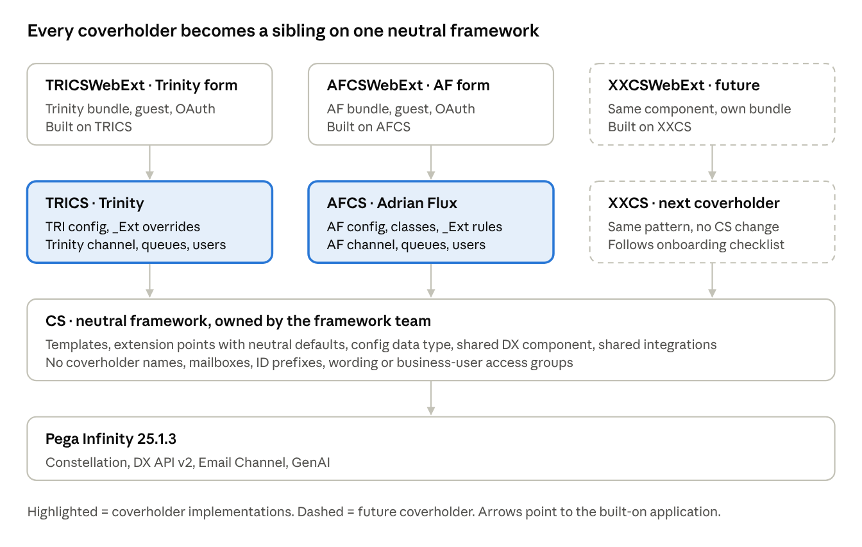
future application stack · framework + sibling implementations
Generic logic flows down into CS only; everything coverholder-specific sits in the implementation above it, so a CS change is reviewed once for all coverholders.

Why it is worth doing
- Governance: a change in CS is by definition a framework change for every coverholder; a coverholder change never touches CS. Ownership, approval and release cadence follow the layer.
- No silent leakage: today AF inherits Trinity defaults. With neutral framework defaults, a missing AF override fails visibly in testing instead of quietly behaving like Trinity.
- Symmetry: Trinity and AF follow the same pattern, so support, documentation and testing are the same for both.
- Faster onboarding: a new coverholder copies the TRICS/AFCS pattern with no framework change.

Target layering rules
Layer | Holds | Must not hold
CS (framework) | Templates, extension points with neutral defaults, generic data model, shared DX component, config data type, shared integrations (Libra, GenAI), Work-Channel-Triage-Email templates | Coverholder names, mailboxes, ID prefixes, wording and templates, coverholder data rows, business-user access groups or portals
TRICS / AFCS / future <XX>CS | Coverholder classes, _Ext overrides, config row, LOV data, correspondence, channel instances, access groups, queue processors | Edits to framework rules
TRICSWebExt / AFCSWebExt | Bundle, guest operator, OAuth client, branding | Business logic
The framework is built-on only: no end-user access groups point at CS directly, only developer and test access groups.

Incremental migration (no big bang)
- Create TRICS, move nothing. TRICS built on CS, ruleset TRICS. Point Trinity access groups, Okta mapping and the Trinity web app's built-on at TRICS. Behaviour is identical; this release only changes context.
- Move Trinity configuration. Move the TRI config row and the Trinity LoadAppContext into TRICS. Make the CS LoadAppContext neutral, raising a clear error when no implementation overrides it, so a misconfigured app fails fast.
- Move Trinity _Ext defaults, one capability per release. Order: those AF also overrides first (they are where leakage happens), then correspondence, PDF, duplicate rules, parsing, validations, triage _Ext rules. For each, save the Trinity version into the TRICS ruleset (same class), then replace the CS default with a neutral one.
- Move channel and background context. Trinity email channel service package to TRICS:Background; Trinity queue processors and job schedulers to TRICS access groups.
- Web app. Create TRICSWebExt built on TRICS with the Trinity bundle, guest operator and OAuth client, or rebuild CSWebExt on TRICS and keep its name until a convenient URL change.
- Clean up CS. Scan CS rulesets for coverholder literals, rename Trinity-flavoured rules, lock the framework ruleset version.
- Optional, later: class move (see the options below).

Class strategy for Trinity cases
Option | How | Pros | Cons
A. Keep HCC-CS-Work-FNOL (recommended now) | Trinity cases stay in the CS class; Trinity rules live in the TRICS ruleset on that class | No data migration; fits steps 1–6 | Trinity differs from the AF class pattern; framework class holds instances; ruleset overrides are less visible
B. New HCC-TRI-CS-Work-FNOL for new cases | From a cutover date new Trinity cases use the new class; in-flight cases finish in the CS class under TRICS ruleset overrides | Same pattern as AF; framework class eventually has no new instances | Two classes and tables for Trinity during the drain; reports span both
C. Migrate all Trinity cases to a new class | Change class of existing cases | Cleanest end state | High risk: class change on cases, history, attachment links, assignments, SLA items; not recommended
Prefer A now and B when a major Trinity change justifies it. With B, keep the TRI- prefix and ID sequence so Libra, emails and claimants' references keep working.

Naming adjustments
- Rules with coverholder names in CS (for example a Trinity validation email): create a generic rule (PolicyValidationRequest), repoint callers, withdraw the old one. Check references held as strings in data instances, DSS and config before withdrawing.
- Properties with coverholder names: do not rename stored or optimized properties in place. Add a generic property and migrate, or keep the old name with a clear description; renaming a column needs DDL and data migration.
- Framework name: keep CS as the framework name to avoid churn, and document that CS means framework. A rename to something like CSFW costs a full regression for little gain.
- Data classes: HCC-CS-Data-LOV holds Trinity values today. Plan HCC-TRI-CS-Data-LOV with its own table; the CS class keeps the structure and, if useful, genuinely shared values.
- Convention: HCC-<Framework|Impl>-<Work|Data|Int>-<Name>, _Ext suffix for extension points, coverholder codes TRI, AF.

Governance model
- The framework team owns CS. Every CS change request carries an impact assessment for all implementations and design-authority approval.
- Version the framework (CS:01-02, 01-03 …). Implementations pin a CS version in their application rule and upgrade on their own schedule.
- Treat extension points as a contract: documented inputs, outputs and default; deprecate rather than remove, keeping the old one for at least one release.
- Add a test implementation app (CSTEST, neutral coverholder) that runs the framework scenarios with no Trinity or AF rules. If it passes, the framework works on its own.
- Pipeline: a CS change triggers regression of CSTEST, TRICS and AFCS; an implementation change triggers only its own.
- Automated checks on CS: no coverholder literals, guardrail score threshold, no new rule without an extension-catalogue entry.

Other points to plan for
- Users across coverholders (shared supervisors, MI): give them one access group per coverholder app, or a separate operations/MI application built on CS with read-only roles, rather than one access group seeing all.
- Keep the stack shallow: framework + implementation + web app is enough; avoid a further layer per line of business unless there is real variation.
- Pega upgrades land in the framework first, then each implementation retests.
- Do not move everything at once: each step above is small enough to release and roll back on its own.

